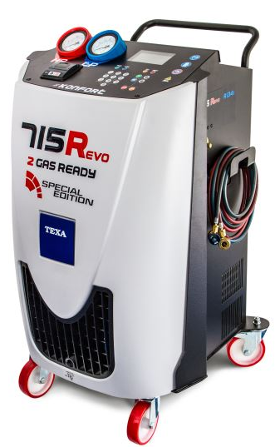

MAIN FEATURES:

R134a / R1234yf compatible
High visibility colour TFT display
Database: CAR, TRUCK, AGRI
Management of DATABASE and service records by SD card
20 kg internal tank
100 l/min double stage vacuum pump
Charging accuracy +/- 15 g
High efficiency refrigerant recovery (over 95%)
New technology main scale shock absorption
Electronic scales for new oil and used oil
UV injection (timed function)
Automatic HP/LP valves
Multi-language software*
Automatic compensation for length of recharging lines
Automatic maintenance alarm
Simplified maintenance
Automatic management of non-condensable
Thermal printer
PVC cover
2 years warranty
Functioning modes:
- DATABASE
- PERSONALISED SERVICE
- MY DATABASE
OPTIONAL:
Refrigerant identifier,
Vehicle flushing kit
Service hoses extension set (up to 12 meters)

ONLY in INTER CARS!!!
KONFORT 715Revo SPECIAL EDITION

AUTOMATIC AIR CONDITIONIG RECHARGE STATION for R134a / R1234yf

(for R134a)
Index: TEX 715R EVO

(for R1234yf)
Index: TEX 715R EVO/HFO

(*) software languages available:

CROATIAN, BULGARIAN, CZECH, DANISH, DUTCH, ENGLISH, FINNISH, FRENCH, GERMAN, GREEK, HUNGARIAN, ITALIAN, JAPANESE, POLISH, PORTUGUESE, (BRAZIL) – PORTUGUESE, ROMANIAN, RUSSIAN, SERBIAN, SLOVAK, SLOVENIAN, SPANISH, SWEDISH, TURKISH.

Indeks: TEX 715R EVO (do obsługi czynnika R134a)

Indeks: TEX 715R EVO/HFO (do obsługi czynnika R1234yf)

